

**Universal Mapping Tool**

Overview & Features

Electronic Products Department

July 25, 2019

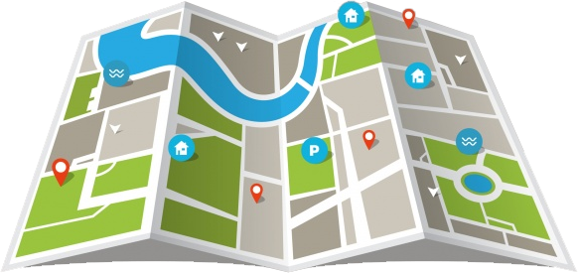

Table of Contents

Phase One Overview 2

Map It! Key Features 2

Map It! Launch Locations 2

Map It! Iterations 2

Phase One Expectations 3

Key Features 3

Key Features Continued 4

User Interface prototype 6

Notes 7

# Phase One Overview

Phase One of the **Universal Mapping Tool (GeoXplorer)** will be a replacement of the current **Map It!** tool currently used on search results and entity profile pages. The application will include all of **Map It!**’s base functionality as well as additional features outlined within this document.

## Map It! Key Features

Basic features for all iterations of **Map It!** :

* **Result Index**
  + List of markers associated with the requested data
* **Map Layers**
  + NERC Regions, Transmissions lines, Coal Beds, Oil & Gas Basins, Resource Plays
* **Basic Results Summary**
  + Displaying X,XXX of XXX,XXX Results

## Map It! Launch Locations

The Map It! function can be launched from within the following places:

* **Search Results Pages**
  + Project, Plant, Unit, Boiler, Drive, Mining Equipment, Other Equipment, Offline Events, Pipeline, Production Field, Transmission Line
* **Report / Profile Pages**
  + Project, Plant, Unit, Boiler, Drive, Mining Equipment, Other Equipment, Offline Events, Pipeline, Production Field, Transmission Line

## Map It! Iterations

Depending on the requested resources, additional features are included with the initial **Map It!** features.

* **Transmission Line Search**
  + Transmission Line Connections points
  + Point A to Point B Poly Lines of Transmission lines
  + 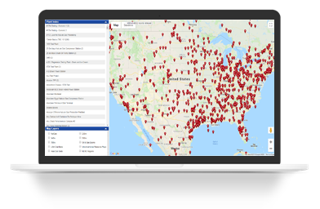Markers for:
    - Origination
    - Destination
    - Connection points
* **Pipeline Search**
  + Pipeline Connections points
  + Point A to Point B Poly Lines of Pipelines
  + Import and isolate Pipeline Systems
  + Markers for:
    - Origination
    - Destination
    - Connection points
  + Toggle Markers and Lateral Pipelines

# Phase One Expectations

The ultimate goal of the **Universal Mapping Application (GeoXplorer)** is to have one GIS based application to incorporate the features of all the GIS based applications.

## Key Features

Features of the **Universal Mapping Tool (GeoXplorer)**:

* **Address Search**
  + Allows user to search for a specific address and drops an interactive pin on the map
  + Address Search field
    - 
  + *Marker Placement*
    - 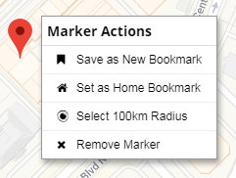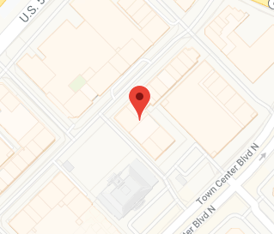
  + Right-click on marker has the following options
    - Save as New Bookmark
    - Set as Home Bookmark
    - Select 100km Radius
    - Remove Marker
* 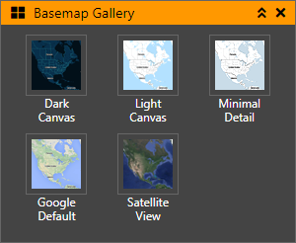**Base Map Gallery**
  + Different color schemes and detail levels for base map
    - Dark Canvas
    - Light Canvas
    - Minimal Detail
    - Google Default
    - Satellite View
  + Persists selection do load the same each time the application is launched
* 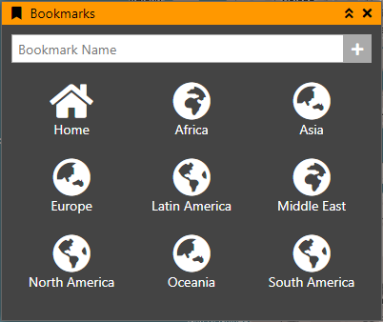**Bookmarks**
  + Saved Locations for the user to recall
  + Defaults to IIR Market Regions
    - Africa
    - Asia
    - Europe
    - Latin America
    - Middle East
    - North America
    - Oceania
    - South America
  + Users can save and name their own Bookmarked Locations
    - 
  + Ability to Edit & Delete bookmarks
    - 
  + Can set Custom Home location for Home UI button

## Key Features Continued

Features for the **Universal Mapping Tool (GeoXplorer)**:

* **Coordinates Bar**
  + Shows coordinates of mouse cursor relative to the map in decimal degrees
    - 
  + Cross-hair next to coordinates bar toggles Point Select Tool
    - Click to copy current Lat/Long coordinates to clipboard
    - 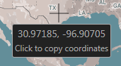
* **Custom Context Menu**
  + Used throughout the application
  + Options change based on what was clicked on
  + 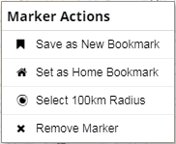Marker Actions
    - Save as New Bookmark
    - Set as Home Bookmark
    - Select 100km Radius
    - Remove Marker
  + 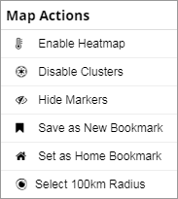Map Actions
    - Enable/Disable Heatmap
    - Enable/Disable Clusters
    - Hide/Show Markers
    - Save as New Bookmark
    - Set as Home Location
    - Select 100km Radius
* **Data Layer Results Summaries**
  + Top level summary of data layer results
  + Many different metrics depending on criteria and data results
    - Displaying X,XXX Results
    - $XX,XXX TIV
    - XX MW Offline
* **Filtering of Data Layer Results**
  + By industry legend & selection tool
  + Filtering would not re-query data layer, but would hide / show markers and data table results based upon selected filter criteria
  + 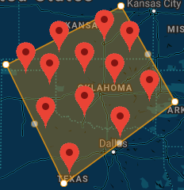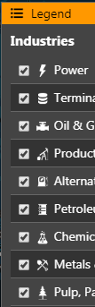
* **Graphing of Data Layer results**
  + Multiple graphing options to visualize results
    - Bar, Column, Pie, Line, Area
  + Will have enough info from data table to create some simple overview graphs
  + Can use the same endpoints as the Search Results Graph By options
* **Heat Map / Density Visualization** 
  + Converts Marker Data to Heat Map visualization with customizable options
    - Hide/Show markers, Pulsing visual, Custom gradients
  + Displays configuration options when active
  + Toggle button on bottom map toolbar
* **InfoWindows**
  + Similar to Disaster Impact Tracker
  + Vertical tabbed for multiple points on same Lat/Long
* **Legend**
  + Industry Icons and definitions
  + Marker symbol definitions
    - Origination, Destination, Connection Points, Pipelines, Clusters, etc.
* **Map Layers**
  + Same layers as the **Map It!** tool
    - NERC Regions, Transmissions lines, Coal Beds, Oil & Gas Basins, Resource Plays, Disaster Polygons, and others
* **Marker Features**
  + Color coded
  + Icon
  + Pulse
  + Status Indicators
* **Marker Clustering**
  + Toggleable grouping of markers on base map
  + No configuration options
* **Overview Map**
  + Displays current extent of the map with context to larger area and updates whenever the map extent changes
  + Can expand and collapse as well as change main map extent from within overview map
  + *Currently in fully functional state*
* **Results Data Table**
  + Data Table at the bottom of the page for Data Layers
  + Can search within data table and sort columns
  + Same columns as results pages depending on what tool is referenced
* **Selection Tools**
  + Polygon Selection
    - Filter/select results within the polygon (similar to Geolocator Radius Search)
  + Radius/Circle Selection
    - Filter/select results within the circle (similar to Geolocator Radius Search)
  + Rectangle Selection
    - Filter/select results within the rectangle
  + Point Selection
    - Gets Latitude & Longitude of a point on the map
    - Same as Coordinates Bar functionality
    - *Currently in fully functional state*
* **User Interface Themes**
  + Options to change the UI theme
    - Dark, IIR Light, & Monochrome

# User Interface prototype

Results Per Page

Zoom Out

Coordinates Bar

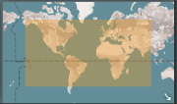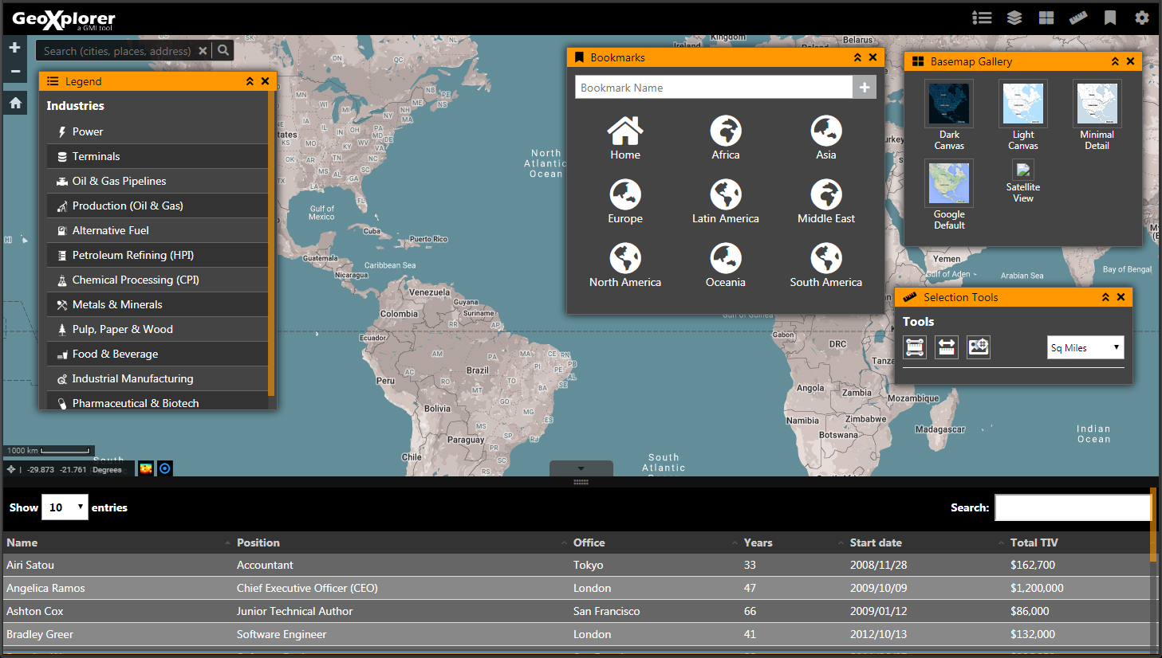

Overview Map

Toggle Data Table

Home

Resize Data Table

Search Table

Address Search

Zoom In

Bookmarks

Settings

Selection Tools

Map Layers

Base Map Gallery

Legend

Toggle Heatmap

Toggle Clusters

# Notes

__________________________________________________________________________________________________________

__________________________________________________________________________________________________________

__________________________________________________________________________________________________________

__________________________________________________________________________________________________________

__________________________________________________________________________________________________________

__________________________________________________________________________________________________________

__________________________________________________________________________________________________________

__________________________________________________________________________________________________________

__________________________________________________________________________________________________________

__________________________________________________________________________________________________________

__________________________________________________________________________________________________________

__________________________________________________________________________________________________________

__________________________________________________________________________________________________________

__________________________________________________________________________________________________________

__________________________________________________________________________________________________________